Ai model to calculate all traveling route and their transportation cost

## Harshita Kandpal , Anshika Singh , Anchal Shukla

Department of Computer Science Engineering, Galgotias University

**Abstract**

In today’s world of fast globalization, transportation planning has never been more important to different industries than now. It helps in cutting costs and finding the best routes. This paper introduces an AI model that can find all possible paths between many locations and their costs along transportation. The model is based on smart algorithms that take into consideration all types of transport modes (road, rail, air, sea) and current data on fuel prices, tolls or traﬀic so as to come up with the real cost value for logistics expenses. Our AI not only calculates but also sorts the routes in two different ways— one based on cost-effectiveness and the other based on distance. This way users can choose what suits their needs best: whether they want to minimize expenditure or reach destination soon enough. We describe the structure of our AI: how it collects information about fuel prices or route lengths; what mathematical methods are used to calculate total costs; which factors influence final decision on sorting routes. Additionally, the paper explores the use cases of the model in logistics sup- ply chain management and urban planning. It clearly shows how this model can help improve decision-making processes and bring about cost effective economic projects to these respective sectors. The AI model is seeking to make a substantial contribution to transportation logistics through automation and optimization of route planning which in turn provides a strong tool for reducing costs and streamlining operations within the field.

**Keywords:** Route Calculation, Artificial Intelligence, Path Optimization, Cost Effective, Dijkstra

# Introduction

Eﬀicient travel planning holds a high place for both individuals and business entities in this whirl- wind modern-day life. The idea of optimizing routes is from now on wedded to daily commutes, oﬀicial tours, or transport and logistics operations— and it has never been more crucial to minimize the cost of these. The conventional methods face a tough time tackling the complexity of present day transportation networks teeming with numerous options and factors using which they can create such a system; thus, diﬀiculty arises in identifying all potential travel routes (including the cost) based on distance plus sorting these routes by both parameters. These conventional techniques are frequently preset routes that are diﬀicult to modify in real-time [1]. Due to their narrow optimization and preference for a single factor—the shortest distance—instead of larger, more significant considerations like cost and fuel economy, they suffer diﬀiculties. As a result, it is one of those problems that needs to be resolved in order to get past the previously listed challenges. The aforementioned problems could be resolved with the use of machine learning algorithms, real-time data integration, and predictive analytics through the application of contemporary techniques like artificial intelligence, which is even more effective and eﬀicient. By figuring out the most economical and eﬀicient route, this technology will address issues with human logistics expertise and increase the overall effectiveness of the transportation network [2] [3].

Consequently, researching the best ways to use AI technology in logistics distribution route optimization is not only a pressing concern in the field of logistics management, but it is also essential to raising the logistics sector’s level of competitiveness. It is anticipated that the outcomes of this line of inquiry will support logistics firms’ decision-making with scientific data, which will advance technology and boost the sector’s overall profitability.

The significance of this study is to reflect the following aspects. First, this study builds a mathematical model that can make decisions based on multiple criteria by using a genetic algorithm (GA). Through emulating natural selection, the GA effectively investigates a large number of possible travel paths. Every route is assessed using a range of criteria, including price and distance. Through this iterative process, the GA finds the best solution to the transportation problem, balancing supply and demand limitations and lowering overall transportation costs [4].

Second, this study will assist logistics firms in addressing the many known and unknown elements that impact transportation and finding solutions that lower operating costs and enhance service quality—two things that are crucial for differentiating themselves in this cutthroat industry. Additionally, it will aid in lowering energy usage and carbon emissions, which is crucial for advancing sustainable development from a societal standpoint. Furthermore, it will assist us in developing the most precise multi-index decision-making model [5].

A thorough examination of the use of Artificial Intelligence in real-world logistics distribution can enhance relevant predictions for upcoming scientific investigations and technological advancements. Generally speaking, this study addresses every facet, from technical application to theoretical investigation, algorithm creation to empirical validation, with the goal of offering an extensive and multidimensional framework for analysis and solution for logistics distribution route optimization.

# Existing Work

This subsection discusses existing travelling route management available in the literature. Khallel *et al* [6] presented this research paper in their work which proposed method for real-time traffic management improves system efficiency up to 97% by using AI-driven route management and cluster-based computing. Through simulation results under a large range of scenarios the proposed approach sees less traffic congestion and control error while performing better than the state-of-the-art algorithms. In [7], Chang *et al* presented a 3D GIS that was employed to provide an accurate overview of voyage data as it is planned — sailing up the Arctic Northeast Passages instead of the traditional routes which run through the Suez Canal. Bulk carriers also score up to 30-45% cost efficiency improvement over average using this method. In [8] Hu *et al* presented the system that proposed above optimizes route planning for logistics businesses by using Google Maps, a multilayer perceptron model and Dijkstra’s Algorithm. This is both effective in predicting traffic status, able to add more stops, and improved transportation efficiency thus greatly reducing the phenomenon of idling taxis. The experimental results of TAN prove its both feasibility and effectiveness, it can be applied to the practical business scenarios. In [9], Phiboonbanakit *et al* presented the proposed optimization model that can solve the vehicle routing problem (abbreviated as VRP) flexibly in the dynamic e-commerce logistics environment through the use of reinforcement learning and the tree-based regression method, enhancing flexibility and expandability. Experimental results show that this new method is able to improve logistics efficiency and to be much more profitable compared to the traditional methods and up to 37.63% profit increase in some cases thus prove its practicality. [10] He also presented the approach that integrates machine learning with a genetic modeling was able to reduce the need on this re-optimization mechanism, hence promoting the robustness and cost reduction in the optimized route in the VRP. It brings a cost reduction until 25.68% compared to traditional methods and the saving increases to 8.10% with respect to a GA. that manage to obtain a gain of 0.72 when estimating customer regions in the future. This will have the benefit of more sustainable urban freight distribution efforts. In [11], Garaix *et al* presented a way of representing vehicle routing issues using graphs, which includes exploring different paths to improve efficiency. Through addressing the fixed sequence arc selection problem (FSASP) using programming and utilizing a branch and price technique the suggested method shows cost reductions, in situations involving on demand transport as confirmed by practical tests, on real world data. In [12], Desrosiers *et al* discusses progressions in time route planning and coordination focusing on the shift, from informal techniques to efficient algorithms. It delves into types of challenges such as managing vehicle routes within specific time windows. Explains how the Dantzig Wolfe decomposition/column generation method is used in a cohesive manner, for organizing fleet and staff schedules. In [13] G.Coa presented this research that introduces an multi index mathematical framework and method, for solving transportation challenges in different ways leading to substantial savings in both expenses and time. Through experiments it has been shown that the suggested approach successfully identifies the transportation strategies and paths resulting in a 12.34% decrease, in transportation related risks. In [14], Xiao *et al* gives an account of how the Fuel Consumption Rate* (FCR) is incorporated into the Capacitated Vehicle Routing Problem (CVRP) so that we can reduce fuel costs in transportation logistics. The paper proposes a mathematical optimization model and a string-based calculation method for the Fuel Consumption VRP (FCVRP). A simulated annealing algorithm was developed which shows good performance in solving CVRP as well as FCVRP, with 5% on average lower fuel consumption than traditional CVRP models being possible. Furthermore, factors influencing variations of fuel consumption are identified and discussed thus giving reasonable insights on optimization of transport system. In [15], Mnif *et al* presented a survey on the currently existing literature on the topic of dealing with transportation problems and their derivatives, in a case that is concern with multimodal transportation specifically. It does not just describe the efficiency of optimization techniques in tackling such questions but also finds flaws in current approaches for different criteria and objective functions. Proposed taxonomy puts into groups factors and criterions which affect multi-objective optimization when solving problems of a transportation network. The writers dwell upon a multi-objective mathematical model proposed for solving problems of multimodal transportation network planning, which gives useful ideas on how to deal with complex yet effective transportation issues. In [16], Ericsson *et al* presented this project that was done to create a navigation system that will help in saving of fuel and reducing CO2 emissions by giving you hints on how to use less fuel even if it is faster to walk than to drive. Based on the real time traffic data of Lund, Sweden, this study shows that almost half of all trips could save an average of 8.2% fuel by using a feather-optimized navigation system. Results from probe vehicles in live traffic demonstrated potential for greater fuel economy particularly in congested environment prompting the need of identifying and announcing disruptive events for improved environmental benefit system.

# Motivation (Problem in Previous Idea) -

Earlier attempts to solve the multi-index transportation problem have faced several key issues. The multi-index approach aims to achieve multiple goals at once during transportation. The main goal has been to reduce transportation costs, which is very important. However, other goals like keeping the goods in good condition and minimizing damage during transit have not received enough attention. Also, the time it takes to transport goods, which is linked to the route length, has often been overlooked. Planning effective routes requires considering all supply and demand factors and assessing route risks, which is complex. Traditionally, mathematical models have been used to calculate transportation costs on complex routes, with genetic algorithms helping to find the best routes.

Despite these efforts, experiments have shown problems in estimating costs and risks for different transportation methods using these models and algorithms. Using artificial intelligence for route planning has highlighted the diﬀiculties caused by varying supply and demand locations and the many possible routes. Different transportation methods add more complexity, making it hard for the models and algorithms to balance cost and risk effectively. While artificial intelligence can suggest many potential routes, accurately estimating the risks and costs for these routes is still challenging. These problems have made route planning less eﬀicient and reliable, showing the need for better methods to ensure safe and cost-effective transportation of goods. Depending entirely on the real-time traffic data provided by probe cars could sometimes be neither accurate nor reliable. The reasons being, among others, the fact that despite growing number of probe vehicles there still may exist areas with limited or no coverage; inaccuracies in information received from the probes; and finally unexpected events/ incidents, which can disrupt/ delay safe and efficient flow of normal traffic, making it difficult to accurately identify real-time traffic problems. Such scenarios can either make drivers get suboptimal route suggestions or have delays even though they followed direction given by the navigation system. Moreover, a system as above may, in case of implementation, demand a lot of technology and infrastructure investment; as this will also need quite significant cooperation between different stakeholders like government agencies, transport authorities ; vehicle manufactures and so forth . Also challenges may arise with respect to ensuring that large numbers of people would use it or letting it become useful since some individuals might be worried about their data privacy or are reluctant to give up their existing wayfinding habits for adopting an alternative one. One issue which impedes the idea is the lack of clarity and details within his suggested taxonomy regarding distinguishing factors contributing to different objectives optimisation as well as criteria required for transportation network planning. If a structured and clear taxonomy is not available then for scholars appreciating offered framework significance and its effective application could be problematic issue. Furthermore , providing more examples/case studies illustrating how proposed multi-objective mathematical model solves real-world multimodal transportation problems should promote better understanding article’s practical value for readers as well potential issues related to its implementation In question there is both discussion about multi-index transportation problem along with offer on paper on efficient transportation method model algorithm you make very good points

# Contribution-

# 1. Efficient Route Planning: Our AI model transforms transportation logistics by thinking about all possible ways, using current fuel costs, tolls, and traffic situation to give the ideal route. This saves a lot of time while also ensuring pocket-friendly means of transportation in various sectors.

# 2. Tailored Decision-Making: The artificial intelligence offers users two sorting alternatives (cost-effectiveness and distance) which enable them make informed choices that match their specific needs and preferences. Whether it is cutting down on expenses or reaching destinations faster, our approach lets users decide.

# 3. Streamlined Operations: By automating and optimizing route planning, our AI significantly contributes to cost savings as well as operational effectiveness within the transport logistics sector. In addition to enhancing overall productivity, this promotes economic growth by facilitating smoother supply chain management and urban planning initiatives too.

# 

# Methods

Transportation route optimization has emerged as one of the crucial factors in the entire logistics management process, and this is due to the fact that large-scale transportation networks can be very challenging to manage and coordinate. Correcting path can bring down the expenses when compared with and deliver efficient outcomes and better service delivery. In general, data preparation and visualization are two important stages of data analysis when analyzing transportation problems. This follows a deeper exploration of how to prepare and present data for route optimization through the application of adequate techniques in handling data alongside sufficient techniques in visualization.

Data Preparation

1. Data Collection and Storage

The first step in data preparation therefore entails the collecting of data related to different nodes in the transport network. These nodes depict different points including the warehouse, distribution centers, as well as the delivery points. The collected data is often stored in a structured format and in this case, the data is in a DataFrame form in the Python environment. In the current DataFrame, df, there are many columns which describe nodes in the network and their coordinates are among them.

**start_x:** The horizontal coordinate, precisely the value along the x-axis of the initial point.

**start_y:** It represents the Y coordinate of the first point of the path.

**end_x:** The parameter that designates the horizontal distance in which the line is drawn in the context of the current shape.

**end_y:** This is the value of the y-coordinate in the terminating point of the line.

2. Data Cleaning and Transformation

The second process is data cleansing, where data collected is cleaned and put into the right format for analysis. This step eliminates any possibility of having inaccurate data, incomplete data or even data that lacks quality values. Cleansing of data can comprise of imputing of data gaps, rectification of incorrect data elements and standardization of data format. “Transformation may mean such things as converting coordinates into a format that can be used in a database, or aggregating data to make further analysis easier. ”

3. Identifying Key Nodes

The next major one is concerned with the selection of the first and last nodse for the routio. This is done using specific commands to filter the DataFrame such as the grep or select. dddddd. For instance:

**df[df["start"] == first_node**]: Subsets the data by performing selection on the rows and looking for the rows whose matching value in the first_node column corresponds to the value provided.

**df[df["end"] == last_node]:** It enshrines a method to filter the given DataFrame to get those rows whose ending node is equal to the last_node parameter.

These commands are useful in the identification of specific nodes that are the start and end nodes of the route; information that is essential in the actual computation and representation of the route.

Data Visualization

Visualization is an integration that has a significant factor in the comprehension of data and decision-making procedures. When drawn on paper, the nodes and the routes turns out to be very easy to understand by the stakeholders and use to assess the various problems that may be present in the network or the opportunities that can be taken to enhance the functioning of the network.

1. Scatter Plot Visualization

The initial action in the graph drawing process is to generate scatter plot for the nodes. This can be done effortlessly with the help of the scatter_mapbox link from the Plotly Express interface this being a useful tool for the creation of interactive maps and interface. It designs the location of nodes in a given map, which makes it easier to visualize the geographical location. The map is geo-referenced and placed with zoom level 15 with size of 900px * 700 px, so, the area of interest is well displayed and easy to read.

2. Marker Customization

To improve the visibility of the scatter plot, it also allows the marker’s appearance to be modified using the marker argument. Customization is the process of distinguishing one node from the other by specifying certain characteristics of certain nodes like the start nodes and the end nodes. In this case, the size of all the nodes is given as 12, with the starting and terminating nodes being larger, at 15. The color coding is also distinct: In the drawing of regular nodes, black color is used; start node is in red and the end node is in green. This differentiation proves helpful in determining key points within the network Connection between people can be said to be the ultimate nature of the network.

3. Animated Route Visualization

If one wants to have a more involving or dynamic view, an animated scatter plot may be used especially in representing the selected route. This is especially helpful and convenient in demonstrating how the route evolves over time or in response to the variation in real-time information. This can be very helpful since it gives the animation part which in a lively manner shows the route development and even the changes it goes through if any.

4. Route Line Visualization

The last part used a Euclidean distance algorithm to project a line on the visualization in between the nodes of the map. This is done using the line_mapbox function in order to visualize the nodes, and the function plots a line from one node to the next, creating therefore a line. By the help of this mode, one gets the clear picture of the route to be taken as it shows the line plot of the path the vehicle to be taken. This is useful for considerations such as mapping out of the course and the probable path, in order to determine the best and most effective one.

The most crucial facets of connection planning revolve around data organization and representation for efficient transportation routes. Therefore, with the help of Plotly’s state-of-the-art tool called Plotly Express and trying to follow data handling procedures meticulously, we can produce very correct but interactive graphs that can assist the decision-making process extensively. They also facilitate cost control and lead to higher operational efficiency to raise the quality of service delivery in logistics. This, in turn, means that more informed decisions, based on available data, can be made, facilitating more efficient and therefore more sustainable transport systems.

# Results

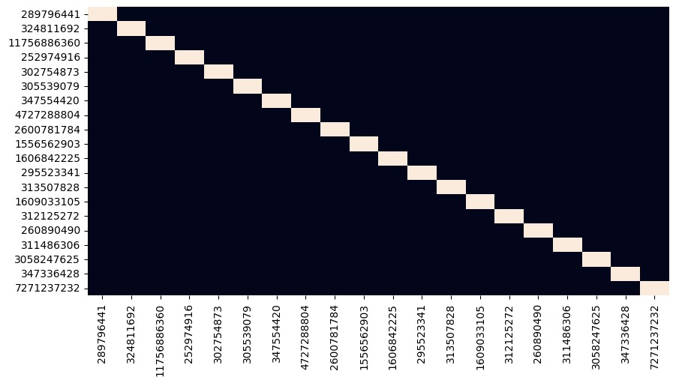

Heatmap Generated between Nodes

Fig.(1)

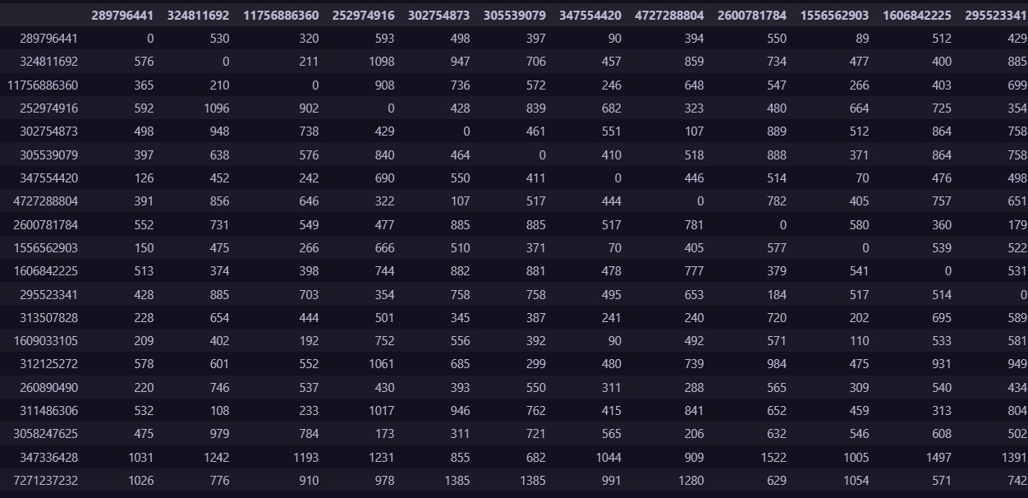

distance_matrix= distance_matrix.round()

distance_matrix=distance_matrix.astype('int')

distance_matrix

Fig.(2)

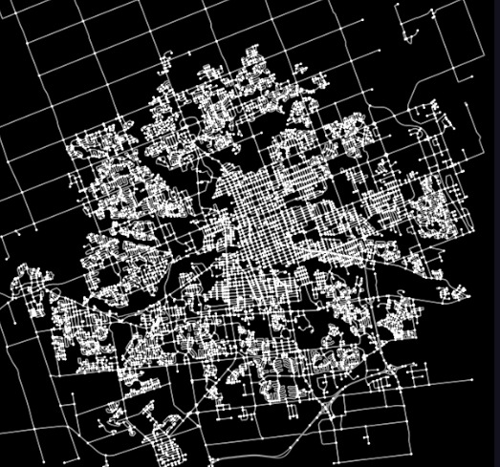

Map generated with the given CSV dataset

Fig.(3)

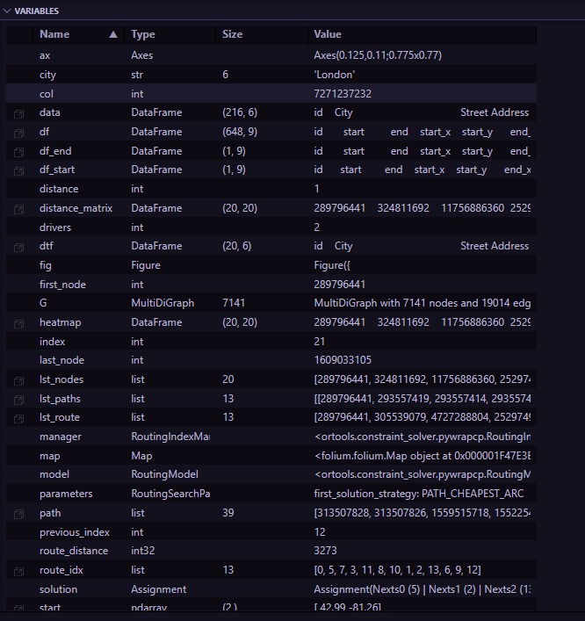

Variables Used

Fig.(4)

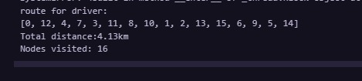

Nodes visited by Driver

Fig.(5)

# Conclusion

To conclude, the issue we dealt with in our paper was how travelers and companies can find the requisite information more efficiently. In order to understand the challenges enumerated above we thought it prudent to develop an intelligent device that encompasses artificial intelligence algorithm, machine learning, accumulated real-time data and that of analytics. The approach of determine the best set of routes as applied in this paper has adopted the work of genetic algorithms in the sense that when constructing the routes, factors that are considered include the cost and the distance in order to cover the supply and demand with minimal transportation cost. We also targeted services on explaining how various logistics firms dealing with several transport challenges and how the cost of service delivery of functional logistics costs could be reduced and the quality of services that meet the needs of the challenging, competitive and market-oriented environment enhanced. Relating the use of AI to real life logistics, we found ways on how the AI use can add a physical additional level on which future advancement in technology and science can base itself on. It thus broadens from providing computer algorithms in a technical context, and analysis of the theory behind them right to creating algorithms and engaging in the research to prove algorithms theory. In a more detailed manner our research is focused on the following points: our studies enrich the knowledge about the factors influencing decisions and contribute to the development of the logistics industry and the increase in total productivity and profitability.

**References-**

**[1]** A. Polimeni and A. Vitetta, "Vehicle routing in urban areas: An optimal approach with cost function calibration", Transportmetrica B Transp. Dyn., vol. 2, no. 1, pp. 1-19, Jan. 2014. - Google Scholar

**[2]** SP Evans, “Derivation and analysis of some models for combining trip distribution and assignment” - Transportation research, 1976 – Elsevier

**[3]** Qianfei Liu, “Logistics Distribution Route Optimization in Artificial Intelligence and Internet of Things Environment”, 2024 - researchgate.net - Google Scholar

**[4]** Sabah Mohammed, Hamid R. Arabnia, Xiaobo Qu, Dalin Zhang, Tai- Hoon Kim, Jiandong Zhao, “IEEE Access Special Section Editorial: Big Data Technology and Applications in Intelligent Transportation”, 2020 - ieeexplore.ieee.org- Google Scholar

**[5]** X. G. Luo, H. B. Zhang, Z. L. Zhang, Y. Yu and K. Li, “A new framework of intelligent public transportation system based on the internet of things,” IEEE Access, vol. 7, no. 2, pp. 55290–55304, 2019

**[6]** Improved Transportation Model with Internet of Things Using Artificial Intelligence Algorithm (Ayman Khallel Al-Ani, *, Shams Ul Arfeen Laghari , Hariprasath Manoharan , Shitharth Selvarajan and Mueen Uddin)

**[7]** Route planning and cost analysis for travelling through the Arctic Northeast Passage using public 3D GIS( K.Y. Chang,S.S. He,C.C. Chou,S.L. Kao &A.S. ChiouEnglish Lang )

**[8]** OPTIMAL ROUTE PLANNING SYSTEM FOR LOGISTICS VEHICLES BASED ON ARTIFICIAL INTELLIGENCE (Wu-Chih Hu, Hsin-Te Wu, Hsin-Hung Cho, Fan-Hsun Tseng)

**[9]** A Hybrid Reinforcement Learning-Based Model for the Vehicle Routing Problem in Transportation Logistics (Thananut Phiboonbanakit; Teerayut Horanont; Van-Nam Huynh; Thepchai Supnithi)

**[10]** Knowledge-based learning for solving vehicle routing problem (Phiboonbanakit, T., Supnithi, T., Horanont, T., Huynh)

**[11]** Vehicle routing problems with alternative paths: An application to on-demand transportation (Thierry Garaix , Christian Artigues , Dominique Feillet , Didier Josselin)

**[12]** Time constrained routing and scheduling (Jacques Desrosiers, Yvan Dumas *, Marius M. Solomon, François Soumis)

**[13]** (G. Cao), “Research on the application of artificial intelligence algorithm in logistics distribution route optimization,” Paper Asia, vol. 34, no. 5, pp. 35–38, 2018.

**[14]** (Y. Xiao, Q. Zhao, I. Kaku and Y. Xu), "Development of a fuel consumption optimization model for the capacitated vehicle routing problem"

**[15]** (M. G. Mnif and S. Bouamama), “Multi-objective optimization methods for transportation network problems,” International Journal of Operations Research and Information Systems, vol. 11, no. 1, pp. 1–36, 2020.

**[16]** Optimizing route choice for lowest fuel consumption – Potential effects of a new driver support tool

(Eva Ericsson, Hanna Larsson, Karin Brundell-Freij)

**[17]** U. K. Lilhore, A. L. Imoize, C. T. Li, S. Simaya, S. K. Pani et al., “Design and implementation of an ML and IoT based adaptive traffic-management system for smart cities,” Sensors, vol. 22, no. 8, pp. 1–26, 2022.

**[18]** D. Devaurs, T. Siméon, J. Cortés, “Optimal Path Planning in Complex Cost Spaces with Sampling-Based Algorithms”, IEEE Transactions on Automation Science and Engineering, Vol. 13, No. 2, pp. 415-424, April, 2016

**[19]** C Mao, Z Shen, “A reinforcement learning framework for the adaptive routing problem in stochastic time-dependent network”, Transportation Research Part C: Emerging Technologies, 2018 - Elsevier